**Executive Summary: Start-up of Tent house and Stage businees**

* Whether it is a small birthday party, wedding ceremony or any other occasion, some people are invited to your home.
* To make some arrangements, some items are required, and some of them are a tent, fan, light, chair, and others.
* Here, the tent house is a common item that is often rented for making additional arrangements at home at times of celebrations and occasions.
* I will invest and planning to start a business, starting a tent house business idea is a good option. With this business of tent house, i can expect to get orders for marriage occasions or any parties. But before i start with this business, we should know about its basic requirements. Read on to know more about the details and requirements of starting this business.

   

**History Of Tent**

* As of recently, scientists found remains of tents in Russia that date back all the way to 50,000 B.C. Many residents in the early years of human life relied heavily on tents until advancements provided more permanent structures. These tents were made of basically what was available to them; leather, wood, and rope.
* The tents are the temporary houses used by many people like nomads to live. It protect ourselves from heat,cold, rain etc just like other type of houses do. Both tents and houses provides us shelter.

**THE FIRST TENT**

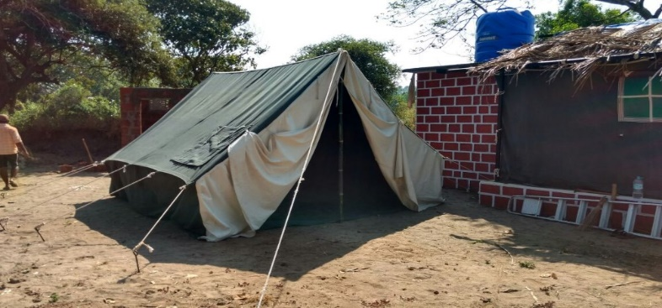

* An alternative to caves or huts, early humans started to make the very first portable shelters as they moved around hunting and gathering, following the

**What are the essential things required for running a tent house start-up?**

* To start the tent house business, some important items are required and some of them are detailed in the following part of the article.
* After the tents have been made, the guests can better meet and relax comfortably in the tents. In addition, you have to arrange for chairs, lights, fans, staying arrangements of guests and others in the tents. Also, sheets and bed linens are required. So, it is important that you buy these items in more quantity so that you do not have any problem to supply them required.
* Even you have to make arrangement for making food and serving them to the guests in the tent house business. So, it is necessary to have a large gas stove in which the food can be cooked. In addition to this, there should be the availability of enough drinking water for the guests. Therefore, you have to arrange for large drums of water.
* For decoration purpose, you have to prepare things like music system, carpet, different types of lights and flower for decorations. The attractive the decoration, the better the client will appreciate your work.

**Market Opportunity:**

* In a month, you can earn almost 25 to 30 thousand rupees. But the earnings can vary during wedding season. The demand for this tent house business is the highest during the peak of wedding seasons. The tents are quickly booked and there is a high demand for tents.
* The profits you earn from this business vary from season to season, like in the wedding season. You get more earnings than the regular season. During peak season, tent house booking highest, and tents quickly booked even on higher rent. So, it is expected that during wedding seasons, profit goes up to rupees 5 lakh.

**How to target customer:**

* The wholesaler offer items at affordable prices. To know about this wholesaler, information about the competition in the market,
* Grab the customers' attention with targeted marketing campaigns on social media and Google. Make sure customers can find your tent store by using Shopify's
* Promoting the Business. The promoting part of tent business has a lot of weightage on how well your business gets successful. These covers branding,
* Develop the business plan: This should include your target market, menu offerings, pricing, marketing strategy, and financial projections.
* Marketing for any business is common and it is also important when you start a tent house business.
* For effective implementation of marketing it is necessary that the news of your business should reach people. Moreover, you have to identify your target group and try out ways so that the news of the business reaches the target group easily.
* By means of local radio channels, you can try to spread the news of your business so that you can expand it and get more customers for your business and earn well. Therefore, try to find out ways of promoting your business effectively.

**Investment details in tent house business:**

* In this kind of tent house business, you do not have to invest frequently. Once you invest, you are ready to go with it for almost 5 to 10 years.
* You only have to take a large number of things at the same time.
* It shall help when you are providing service there should not any shortage of items whether it is for food arrangement or decoration part.
* So, if you are starting with this business, you have to spend near about 1.5 to 2 lakh rupees for the initial set up.
* But if you are able to invest more and want to make a big set up, you have to pay near about rupees 5 to 6 lakh for the business. In addition,
* there are several other additional expenses that are involved in the tent house business.

**How to get an easy loan for investing in a tent house business?**

* For the ones who have a problem in starting a tent house business and worried about getting a loan, facilities have been made by the government for new employment and getting easy loans.
* The new generation will be helped by the government in getting easy loans.
* However, in this regard, the government has ordered the financial institutions to offer easy loan facilities to entrepreneurs who opt for loans for starting this tent house business.
* This way they can create employment and earn some money for maintaining the better livelihood of their family. So, when starting this tent house business, when you visit banks for loans, you do not have to face problems in getting the loans.

**Risk Assessment:**

* Exposure to extreme weather: Tents are not always weatherproof, so families may be exposed to extreme weather conditions, such as rain, snow, or wind,Insect.

**Competitive Advantage:**

* Affordable Pricing: Tent houses offer competitive pricing packages, allowing you to enjoy the benefits of outdoor events or camping without breaking the bank.
* Our professionals are competitive enough to provide extensive multiplicity of fascinating tents that make the occasion memorable for hosts as well as the guests.
* We specialize in decorating the personal and professional events of the individuals. Our company procure high quality decorative furniture, tents and other.
* The global camping tent market is moderately competitive with the presence of many well-known international and local companies operating all around .

**Location & its Advantages:**

* LAND: The proposed location of the Unit is situated at Mondha Village, Hingna Nagpur( Dist.) .
* The location of the industry has considerable influence on the techno-economical facility of the project.
* There are various factors contributing to the functioning of an industry and following are the primary factors taken into consideration.

**REASONS FOR THE SELECTION OF THE SITE:**

* Availability of labor at economically rate.
* The tent house is well connected with road facility
* Banking facilities and Government supports.
* Adequate Transport facilities for economical transportation of finished product and Spare parts
* Nearness to the Market
* As the area is developing area, the setting up of a unit in this will help the people to progress both socially and economically.

**Incentives / Subsidies:**

The following incentives are available for Micro and Small Enterprises (MSE’s):

1. 100% reimbursement of Stamp duty and transfer duty paid by the industry on purchase of land meant for industrial use.
2. 100% reimbursement of Stamp duty for Lease of Land/Shed/Buildings and also mortgages and hypothecations.
3. 3.25% rebate in land cost limited to Rs. 10.00 Lakhs in Industrial Estates/ Industrial Parks.
4. 4.25% Land conversion charges for industrial use limited to Rs. 10.00 lakhs.
5. Fixed power cost reimbursement @ Rs.0.75 per unit (upper ceiling) on the proposed revised rate (2010 -11) for 5 years from the date of commencement of commercial production. Incase decrease in Power Tariff; the reimbursement will be reduced proportionately.
6. 15% investment subsidy on fixed capital investment subject to a maximum of Rs. 20.00Lakhs.
7. Reimbursement of 100% VAT/CST or State Goods and Services Tax (SGST) for a period of5 years from the date of commencement of commercial production to Micro Enterprises.
8. 8.Reimbursement of 50% VAT/CST or State Goods and Services Tax (SGST) for a period of5 years from the date of commencement of commercial production to Small Enterprises.
9. Interest subsidy under Pavala Vaddi Scheme on the term loan taken on the fixed capital investment by New Micro and Small enterprises in excess of 3% per annum subject to a maximum reimbursement of 9% per annum for a period 5 years from the date of commencement of commercial production.
10. Seed capital assistance to First Generation entrepreneurs to set-up Micro Enterprises @10% of the Machinery cost , which will be deducted from the eligible investment subsidy
11. 50% reimbursement of cost involved in skill up gradation and training the local manpower limited to Rs.2000 per person.

**License Process :**

**The following liscence will be required for the starting up the industry.**

1. Part I
2. Single window approvals.
3. Panchayati.
4. Inspector of factories.
5. Pollution.
6. Electricity
7. VAT.
8. Town and city Planning.

**Utilities & Services**

**POWER:** The Unit will need a total connected load of 100.00KW at 3phase ,4wire ,50Hz, A Cand 400/440 Vo.

**WATER**: The unit requires 4,000 Liters of water per day.

**EFFLUENTS:** There are no harmful effluents generated in the process.

**TRANSPORTATION:** The proposed unit is located at (Dist) There is no problem for transportation of raw material and finished goods.

**MANPOWER REQUIREMENTS:** The unit will be employing 6 Nos. of workers besides 2 Nos. of administrative staff. All the above persons can be recruited locally without any difficulties**.**

**Conclusion:**

Tent dealers play a vital role in the event industry, providing essential services to help organizers create successful events.